PROJECT REPORT
Visualizing Housing Market Trends: An Analysis of Sale Prices and Features using Tableau

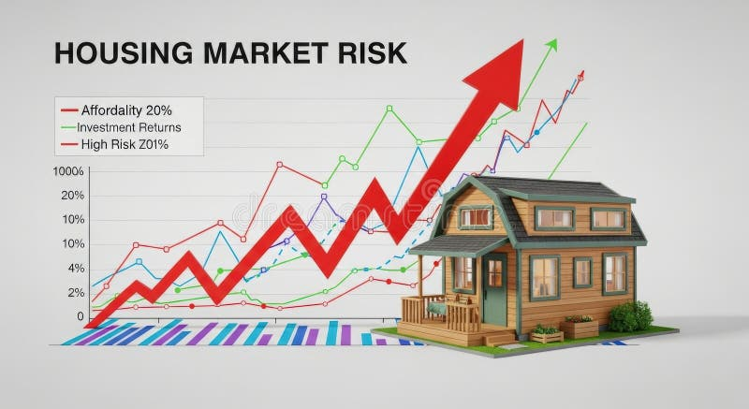
SUBMITTED BY:
Kantamareddy Narayani-narayanikantamareddy@gmail.com
Hasadula Harshitha-hasadulaharshitha@gmail.com

TABLE OF CONTENTS
1.INTRODUCTION | 3
2.IDEATION PHASE | 4
3.REQUIREMENT ANALYSIS | 6
4.PROJECT DESIGN | 8
5.PROJECT PLANNING &SCHEDULE | 9
6.FUNCTIONAL AND PERFORMANCE TESTING | 10
7.RESULTS | 11
8.ADVANTAGES &DISADVANTAGES | 14
9.CONCLUSION | 14
10.FUTURE SCOPE | 15
11.APPENDIX | 15

INTRODUCTION

Project Overview
The Housing Market Trends and Sales Price Analysis project is developed using Tableau to analyze and visualize housing market data. The project aims to transform raw housing data into meaningful visual insights that help users understand factors affecting house prices. Various features such as basement area, sale price, number of bedrooms, bathrooms, floors, house age, and renovation status are analyzed through interactive charts and dashboards.
The project follows a systematic workflow that includes data collection, data preparation, visualization creation, dashboard development, storyboard creation, and project deployment through GitHub. The final dashboard enables users to explore housing market trends easily and supports better decision-making for buyers, sellers, and real estate analysts.

Purpose
The main purpose of this project is to analyze housing market data and present meaningful insights using interactive Tableau visualizations. The project helps users understand how different property features influence house prices and enables them to identify market trends effectively. It also demonstrates the use of Tableau as a Business Intelligence tool for transforming raw data into easy-to-understand visual reports.

2. IDEATION PHASE

2.1Problem Statement
The real estate industry generates large volumes of housing data, making manual analysis difficult and time-consuming. Buyers, sellers, and real estate professionals often struggle to identify pricing trends, compare property features, and understand the impact of factors such as renovation, house size, and number of rooms on sale prices. There is a need for an interactive system that converts complex housing data into meaningful visual insights for better decision-making.

2.2Empathy Map Canvas User
Home Buyers, Home Sellers, Real Estate Agents, Property Investors, Market Analysts

Says
    - I want to compare house prices easily.
    - I need a simple way to analyze housing trends.
    - I want to understand which features affect house prices.

Thinks
    - Which house provides better value?
    - Does renovation increase house value?
    - How do bedrooms and bathrooms affect the selling price?

Does
    - Searches for houses online.
    - Compares multiple property listings.
    - Studies housing market reports before making decisions.

Feels
    - Confused by large datasets.
    - Needs reliable market insights.
    - Wants quick and accurate visual reports.

Pain Points
    - Manual data analysis is difficult.
    - Housing data is complex.
    - Comparing multiple property features takes time.

Gains
    - Easy understanding of housing trends.
    - Interactive visual reports.
    - Better investment and purchasing decisions.

2.3 Brainstorming
During the ideation phase, several possible project ideas related to the housing market were discussed. Different approaches such as house price prediction, property recommendation systems, and housing dashboards were considered. After evaluating the available dataset and project objectives, the team selected Housing Market Trends and Sales Price Analysis using Tableau because it effectively demonstrates data visualization techniques and provides meaningful insights without requiring complex machine learning models.
The brainstorming process focused on identifying the most important housing attributes that influence sale prices and selecting suitable visualizations to represent these insights clearly.

3.REQUIREMENT ANALYSIS

Customer Journey Map
Stage | Customer Activity | System Response
Discover | User wants to analyze housing market trends | Housing dataset is collected
Prepare | Dataset is cleaned and processed | Clean and structured data is generated
Analyze | User explores visualizations | Interactive charts display insights
Compare | User compares property features | Dashboard provides combined analysis
Decide | User makes informed decisions | Storyboard summarizes overall findings
3.2 Solution Requirements
Functional Requirements
    - Import housing dataset into Tableau.
    - Clean and prepare the dataset.
    - Create interactive visualizations.
    - Design an interactive dashboard.
    - Create a storyboard to present the analysis.
    - Upload project files to GitHub.

Non-Functional Requirements
    - Easy to use.
    - Fast dashboard loading.
    - Interactive visualizations.
    - Accurate representation of data.
    - User-friendly interface.

Data Flow Diagram
Housing Dataset
│
▼
Data Collection & Loading
│
▼
Data Cleaning & Preparation
│
▼
Tableau Workbook
│
▼
Create Visualizations
│
▼
Interactive Dashboard
│
▼
Storyboard
│
▼
User Analysis & Insights

3.4 Technology Stack
Technology | Purpose
Tableau Desktop | Data Visualization and Dashboard Creation
Microsoft Excel / CSV | Dataset Preparation
GitHub | Project Repository and Version Control
Windows Operating System | Development Environment

4.PROJECT DESIGN

4.1Problem Solution Fit Problem
Analyzing housing market data manually is difficult due to the large volume of
information and multiple influencing factors.

Solution
The proposed Tableau dashboard converts raw housing data into interactive charts and dashboards that help users understand pricing patterns, property characteristics, and housing market trends quickly and efficiently.

4.2Proposed Solution
The proposed solution begins with collecting the housing dataset and loading it into Tableau. The data is then cleaned and prepared by handling missing values and ensuring consistency. After preprocessing, multiple visualizations are created to analyze different aspects of the housing market.
The project includes the following visualizations:
    - Sum of Basement Area
    - Average Sales Price
    - Count of Housing Records
    - Histogram showing Total Sales by Years Since Renovation
    - House Age Distribution by Bedrooms, Bathrooms, and Floors
    - Pie Chart showing Distribution of Houses by Renovation Status

5.PROJECT PLANNING & SCHEDULING

5.1Project Planning
Project planning and scheduling were carried out to ensure the successful completion of the Visualizing Housing Market Trends and Analysis of Sale Price and Features using Tableau project within the given timeline. The project was divided into multiple phases, including dataset collection, data preprocessing, visualization development, dashboard creation, storyboard preparation, GitHub repository upload, and final documentation.
Subsequently, a storyboard was created to present the analytical process and key insights in a logical sequence. The completed project files were uploaded to GitHub for version control and collaboration. Finally, comprehensive documentation and a project demonstration were prepared to explain the methodology, dashboard features, and findings.
This planned and scheduled approach helped the team manage tasks efficiently, monitor progress regularly, and complete the project systematically within the academic timeline.

Phase | Activities
Phase 1 | Dataset Collection
Phase 2 | Data Cleaning and Preparation
Phase 3 | Visualization Development
Phase 4 | Dashboard Creation
Phase 5 | Storyboard Development
Phase 6 | GitHub Repository Upload
Phase 7 | Documentation and Project Demonstration

These visualizations are combined into a single interactive dashboard, and a storyboard is created to present the complete analytical workflow.

6.FUNCTIONAL AND PERFORMANCE TESTING

6.1Functional Testing
Test Case | Expected Result | Status
Dataset Loading | Dataset loads successfully | Passed
Data Cleaning | Dataset is cleaned properly | Passed
Visualization Creation | Charts display correct values | Passed
Dashboard | Dashboard displays all visualizations | Passed
Storyboard | Storyboard presents project workflow correctly | Passed
GitHub Upload | Project files uploaded successfully | Passed

6.2Performance Testing
Parameter | Result
Dashboard Loading Time | Fast
Visualization Accuracy | Accurate
Dashboard Responsiveness | Good
User Interaction | Smooth
Data Processing | Efficient

7.RESULTS

7.1Output Screenshots
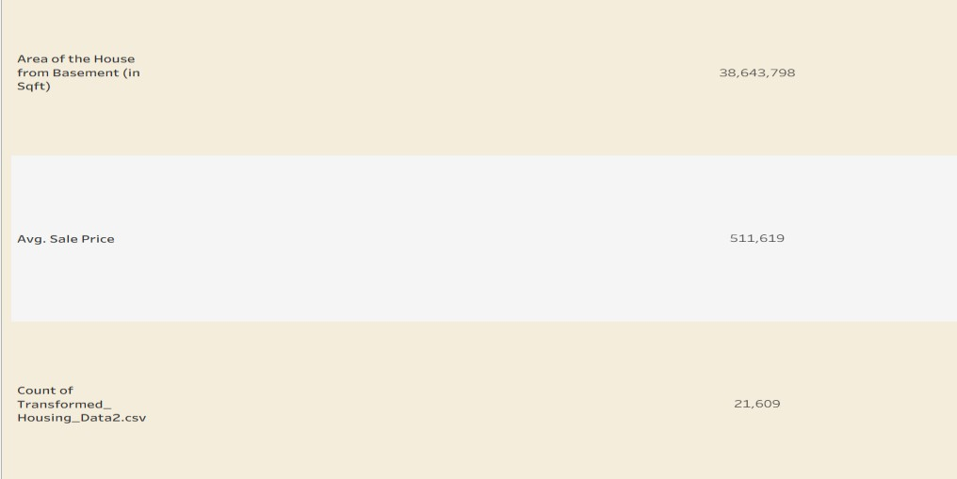
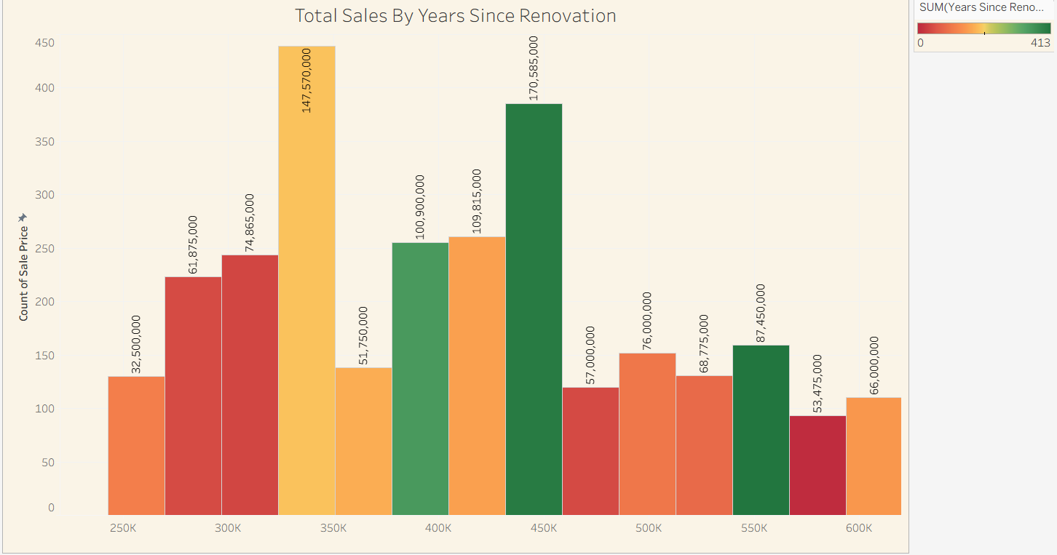
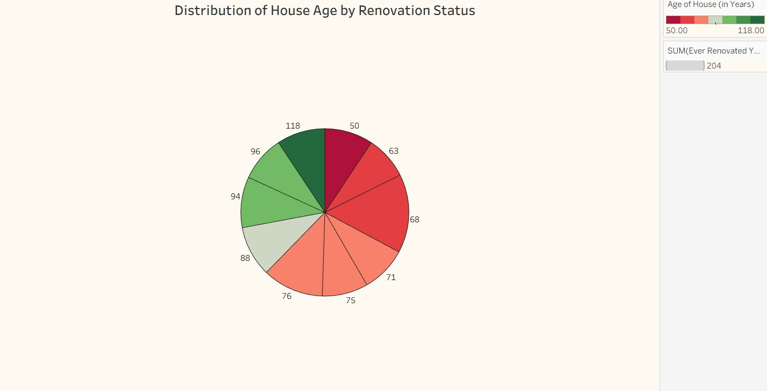
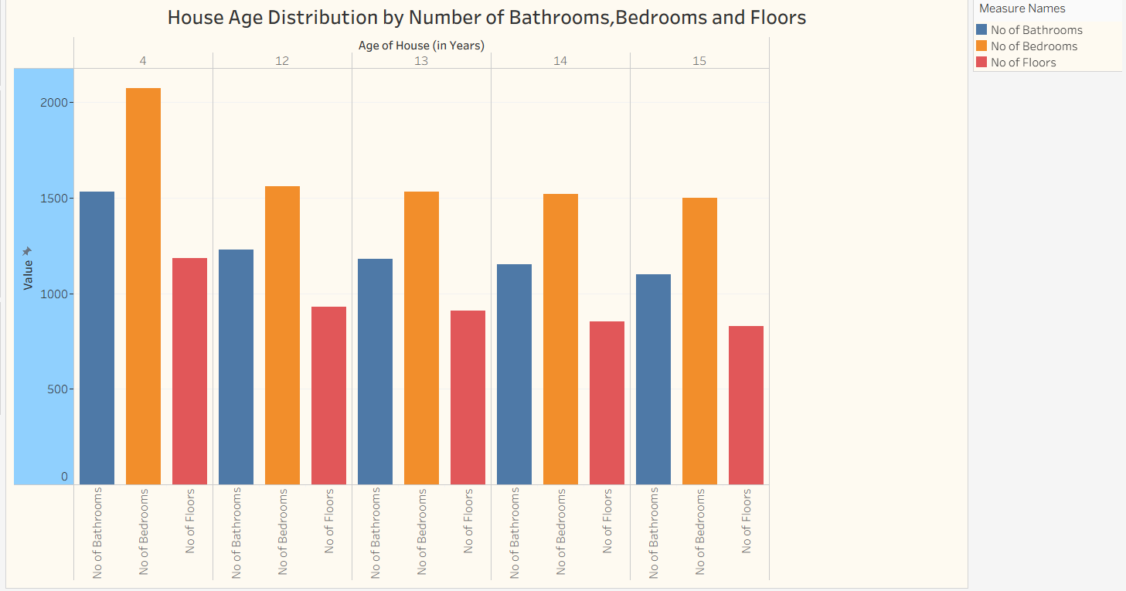
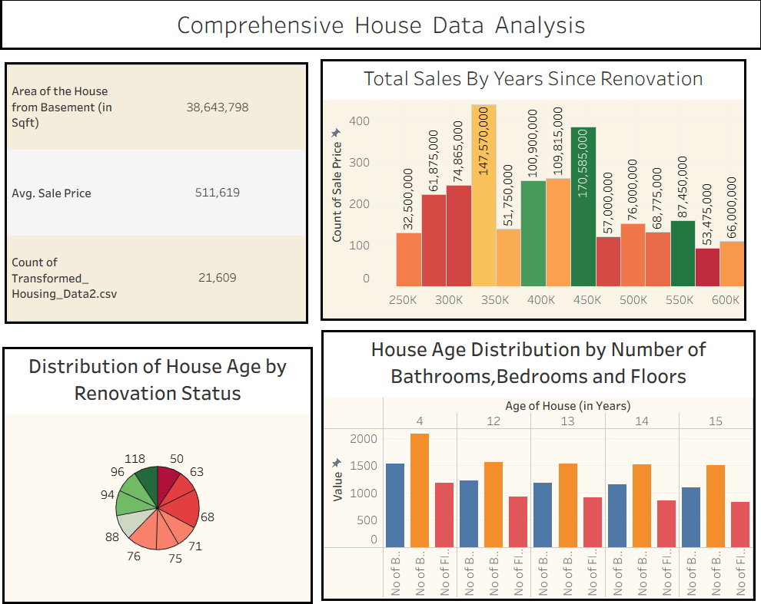
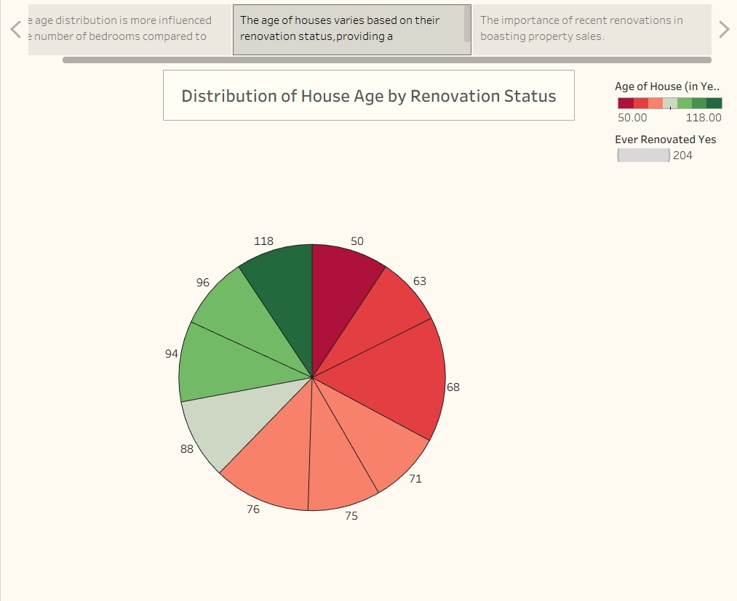

8.ADVANTAGES & DISADVANTAGES

Advantages
- Provides interactive housing market analysis.
- Simplifies complex housing datasets.
- Supports better decision-making.
- Easy to understand through visual representations.
- Saves time in analyzing housing trends.
- Helps compare multiple housing features efficiently. Disadvantages
- Depends on the quality of the dataset.
- Limited to available historical data.
- Does not provide future price prediction.
- Requires Tableau software for editing dashboards.

9.CONCLUSION
The Housing Market Trends and Sales Price Analysis using Tableau project successfully transforms raw housing data into meaningful visual insights.
Through data preparation, interactive visualizations, dashboards, and storyboards, the project enables users to understand housing market trends, compare property features, and analyze factors affecting house prices. The project demonstrates the effectiveness of Tableau as a Business Intelligence tool for presenting complex data in an easy-to-understand format and supports informed decision-making in the real estate sector.

10.FUTURE SCOPE
Future enhancements of the project include:
- Integration with live housing market databases.
- Addition of advanced dashboard filters.
- Predictive house price analysis using Machine Learning.
- Region-wise housing trend analysis.
- Mobile-friendly dashboards.
- Integration with real estate websites for real-time updates.
- Automated report generation.
- Interactive user-based analytics.

11.APPENDIX
This project was developed using Tableau, which is a drag-and-drop Business Intelligence tool. Therefore, no programming source code was required. The Tableau Workbook (.twb/.twbx) contains all visualizations, dashboards, and storyboard components used in the project.

Dataset Link
Dataset Name: House Sales in King County, USA
Dataset Source: https://www.kaggle.com/datasets/rituparnaghosh18/transformed-housing-data-2
GitHub Repository Link
GitHub Repository:https://github.com/Narayanikantamreddy/Apsche-Visualizing-Housing-Market-Trends/blob/main/project.twbx
Project Demo Link
Project Demonstration Video:
https://drive.google.com/file/d/13RhjH_sgr-EzLjEiySDK3I9Iu4rs-TBl/view

